Lecture 2
Layering
- a technique to organize a network system into a succession of logically distinct entities, such that the service provided by one entity is solely based on the service provided by the previous (low level) entity.
- E.g. Application Telnet, FTP, NFS, HTTP. Transmission Media Coaxial cable, fiber optic, packet radio
- It is important to introduce an intermediate layer that provides a unique abstraction for various network technologies.
- Advantages
  - Modularity: protocols easier to manage and maintain
  - Abstract functionality: lower layers can be changed without affecting the upper layers
  - Reuse: upper layers can reuse the functionality provided by lower layers
- Disadvantages
  - Information hiding: inefficient implementations

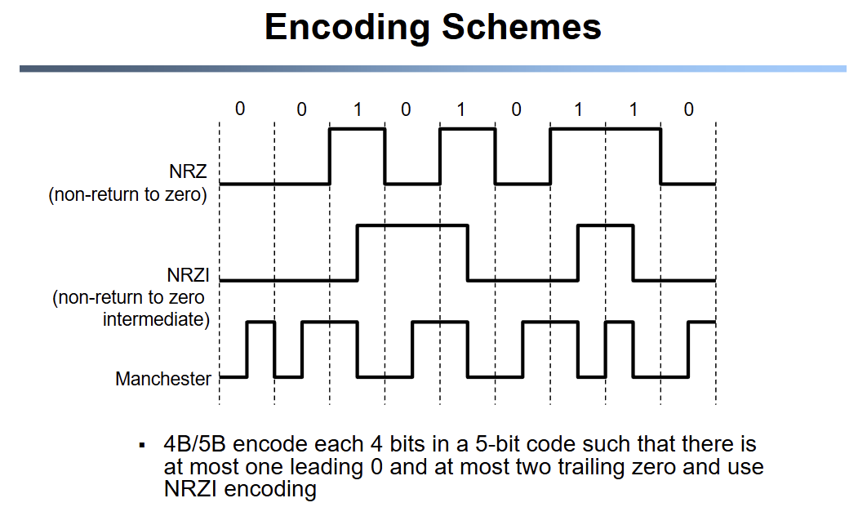
ISO OSI Reference Model
- ISO
  - International Standard Organization
- OSI
  - Open System Interconnection
- Started in 1978; first standard in 1979 to allow vendors to enter the market by using their own implementation.
- Layers
  - Application
    - Service
      - Any service provided to the end user
    - Interface
      - Depends on the application
    - Protocol
      - Depends on the applications
    - Example
      - FTP, Telnet, WWW browser
  - Presentation
    - Service
      - Convert data between various representations
    - Interface
      - Depends on service
    - Protocol
      - Define data format, and rules to convert from one format to another
  - Session
    - Service
      - Full-duplex
      - Access management. E.g. token control
    - Interface
      - Depends on service
    - Protocols
      - Token management; insert checkpoints, implement roll-back functions
  - Transport
    - Service
      - Provide an error-free and flow-controlled end-to-end connection
      - multiplex multiple transport connections to one network connection
    - Interface
      - send a packet to specify destination
    - Protocol
      - Implement reliability and flow control
    - Example
      - TCP and UDP
  - Network
    - Service
      - Deliver a packet to specified destination
      - Perform segmentation/reassembly
      - Packet scheduling and buffer management
    - Interface
      - Send a packet to a specified destination
    - Protocol
      - Define global unique addresses; construct routing tables
  - Datalink
    - Service
      - Framing, i.e., attach frames separator
      - Send data frames between peers
      - Provide flow control and reliable transmission
    - Interface
      - Send a data unit (packet) to a machine connected to same physical media
    - Protocol
      - Layer addresses, implement Medium Access Control (MAC)
  - Physical
    - Service
      - Move the information between two systems connected by a physical link.
    - Interface
      - Specifies how to send a bit
    - Protocol
      - Coding scheme used to represent a bit, voltage levels, duration of a bit
    - Examples
      - Co-axial cables, optical fiber links, transmitters, receivers
Data Transmission
- a layer can use only the service provided by the layer immediate below it.
- Each layer may change and add a header to data packet.
OSI Model Concepts
- Service
  - Says what a layer does
- Interface
  - Says how to access the service
- Protocol
  - Says how is the service implemented

